

**SYSTEM ANALYSIS AND DESIGN**

Charity Second-hand Online Store

Table of Contents

1 Summary 4

1.1 System Objectives 4

1.2 Background 4

1.3 Resource 4

1.4 Costs and Benefits 5

1.5 Milestones 5

2 Current environment description 7

2.1 Current system overview 7

2.2 Current system hardware, software and network 7

3 Requirement Specification 9

3.1 User Requirements Document 9

3.1.1 Proposed System Overview 9

3.1.2 System User Profile 9

3.1.3 Future Business Process 9

3.1.4 Future Business Model 10

3.1.5 Functional Requirements 16

3.1.6 Non-functional Requirements 17

3.2 Technical requirements 17

4 System specification 18

4.1 Architecture Block Diagram 18

4.2 Class diagram 18

4.3 Data Model 18

4.3.1 Entity Relationship Diagram 18

4.3.2 Data Dictionary 18

4.4 Use Case Diagram 18

5 Prototype 19

5.1 Log In 19

5.2 Register 19

5.3 Main Page 20

5.4 Auction Page 20

5.5 My Space 21

5.6 Auction End 22

5.7 My Space For Administrator 23

5.8 Goods Management 24

5.9 About Us 25

5.10 Contact Us 26

# Summary

## System Objectives

We plan to set up an online auction store for the second-hand store. Residents can browse high quality second-hand goods online, and if the auction is successful, customers can make an appointment to pick up the goods, which will greatly increase the number of participants, improve the transaction efficiency and increase the turnover.

## Background

Our client is Zoe Liu who works as an accountant at the Salvation Army church in Lower Hutt. The church has a nationwide second-hand store called Salvation Army Family Store, which collects donated items from residents (clothing, toys, kitchen stuff, etc.). It provides physical stores for residents who like second-hand goods, and the income will be used to fund the operation of the church and help people in difficult areas.

However, the information construction of the second-hand store attached to the church is relatively backward. The store does not have an online store, so it cannot give consumers a better shopping experience.

## Resource

|  |  |  |
| --- | --- | --- |
| Name | **Availability** | **Role** |
| Zoe Liu | 10 Hours (Project Meeting, Change Request) | Client |
| Ian Hunter | 12 Hours (Project Meeting, Project Monitoring) | Project Advisor |
| Guozhi Yin | 450 Hours | Project Manager  Product Designer,  Database Administrator,  Testing  Documentation |
| Cong Shang | 450 Hours | Software Developer  (Front-end, Back-end),  Testing,  Documentation |

## Costs and Benefits

Costs

Since the project team will use open source and free versions of the software development tools, there will be no financial cost to the customer. There is a time cost to the project team, with each member expected to spend 450 hours on project planning, design, development, testing, and documentation.

Benefits

The system is expected to bring the following benefits to our client:

* Promote the information construction of second-hand shops.
* Improve the user experience.
* Increase revenue.

## Milestones

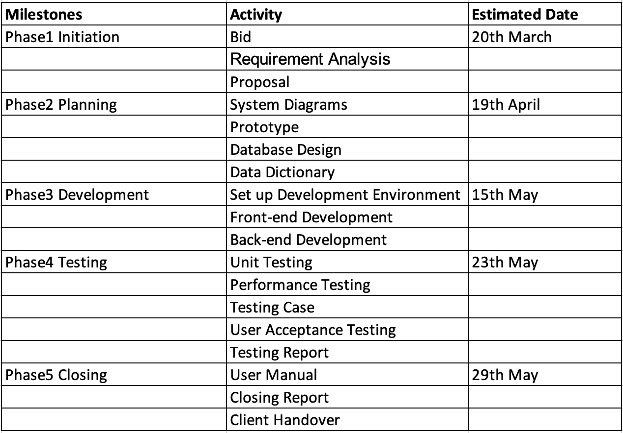

# Current environment description

## Current system overview

The project team will develop a second-hand online auction site for the client, which contains the following main functional modules:

* Registered
* Login authentication
* Search for items
* Auction
* Appointment to pick up

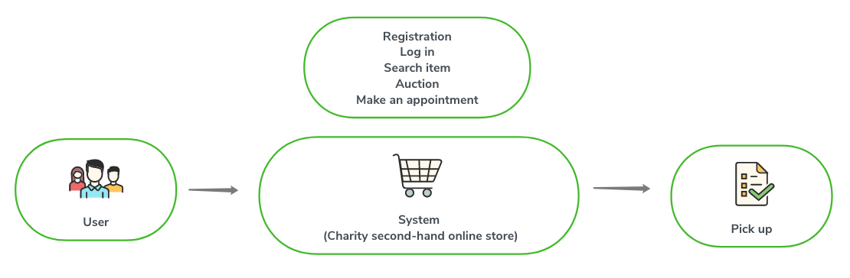

## Current system hardware, software and network

To complete the project, the project team needs to prepare software and hardware resources. To reduce project costs, the project team will try to use free software as much as possible. For the hardware resources, the project team will use our laptops.

The following table shows the resources required for project development and testing:

|  |  |  |  |  |  |  |
| --- | --- | --- | --- | --- | --- | --- |
|  | **Item** | **Version** | **quantity** | **Finish time** | **Remark** | |
| **Software** | | | | | | |
| Database | MySQL | V8.0 | 4 | 3/16/2020 | Michael | |
| Navicat for MySQL | V10.0.11 | 3 | 3/16/2020 | Michael | |
| Application server： | Tomcat | V8.5 | 4 | 3/16/2020 | Cong | |
| IDE | Eclipse | V2019-3(4.11) | 3 | 3/16/2020 | Cong | |
| **Hardware** | | | | | | |
| Laptop | CUP*2  Memory：8GB  DDH：200GB | | 3 | Completed | | Using team member’s laptop |
| Testing server | CUP*2  Memory：8GB  DDH：200GB | | 1 | 4/11/2020 | | Installed MySQL and Tomcat.  Cong is responsible for preparing |

# Requirement Specification

## User Requirements Document

### Proposed System Overview

The proposed Charity second-hand online store would allow users to log in, browse, find items they like and bid on targeted items using a computer or mobile phone. If the bid is successful, the system allows users to apply for a pickup time and go to the store to pickup the goods, pay for the goods and complete the transaction.

### System User Profile

The following provides a table of external and internal users of the website. Each user will have a role in the system.

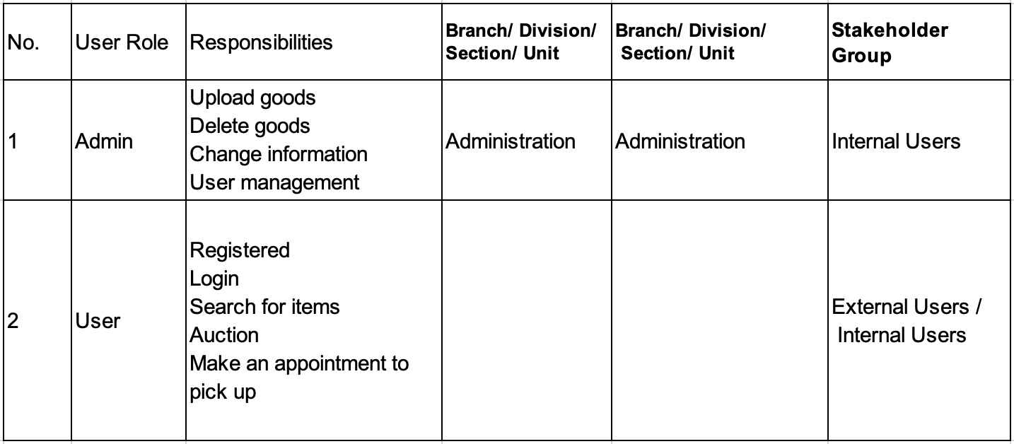

### Future Business Process

#### List of Future Business Processes

|  |  |
| --- | --- |
| Process ID | Business Process Title |
| BP-001 | User Register |
| BP-002 | User/Administrator Login |
| BP-003 | View Goods Details |
| BP-004 | Auction |
| BP-005 | Modify Personal Information |
| BP-006 | Appointment For Pickup |
| BP-007 | Upload Goods |
| BP-008 | Modify Goods |
| BP-009 | User Management |
| BP-010 | Forget password |

### Future Business Model

#### BP-001 User Register

|  |  |  |
| --- | --- | --- |
| User case name: | User Register | |
| Scenario: | User Register | |
| Triggering event: | User wants to register an account | |
| Description: | The purpose of this use case is to create a new user | |
| Actors: | System | |
| Stakeholders: |  | |
| Preconditions: | User does not have an account | |
| Postconditions: |  | |
| Flow of activities: | Actor | System |
| User Register | Create an account. |
|
| Exception conditions: | User had an account before | |

Diagram (Add)

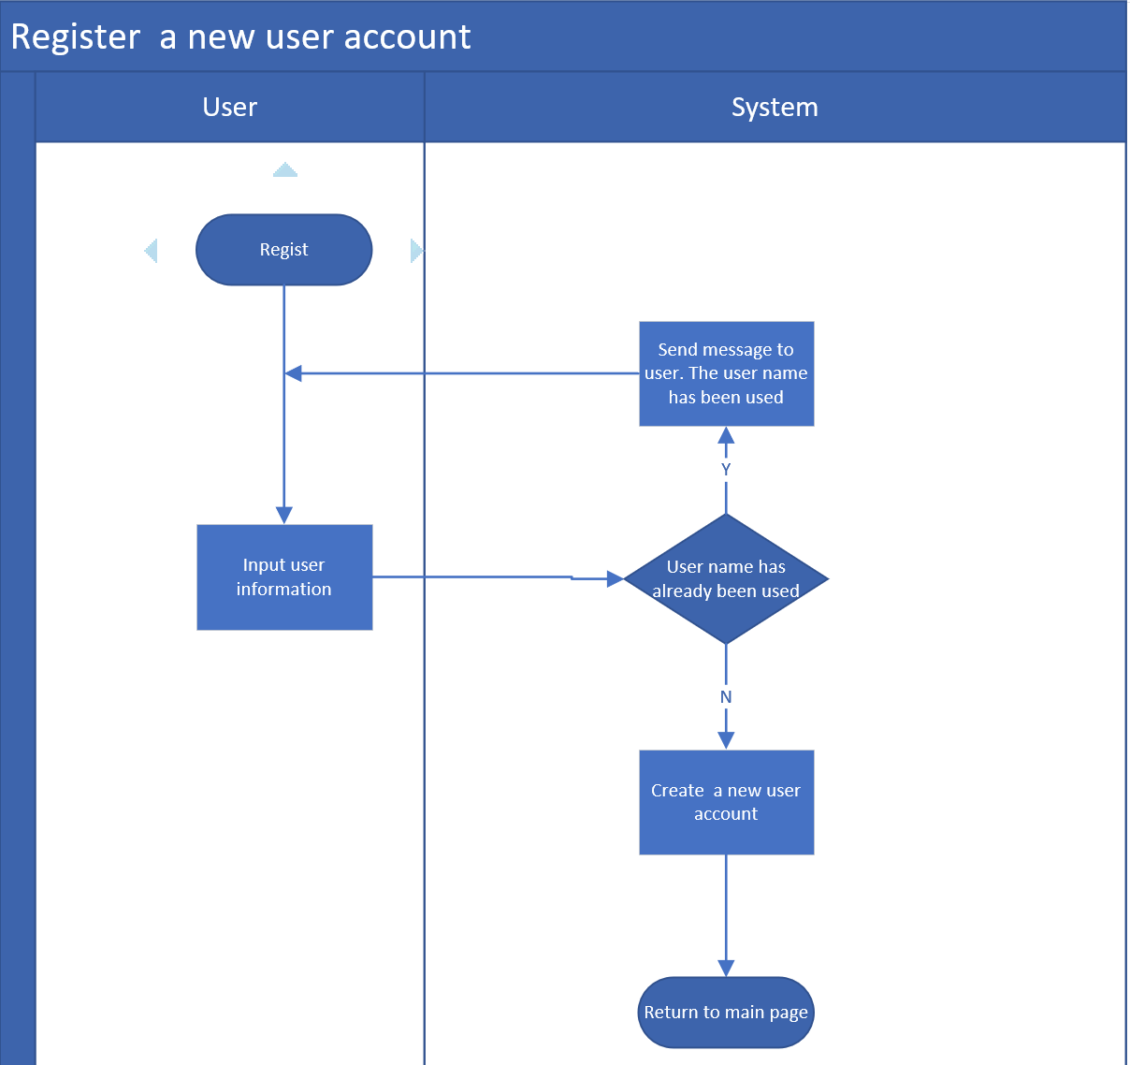

#### BP-002 User/Administrator Login

|  |  |  |
| --- | --- | --- |
| User case name: | User/Administrator Login | |
| Scenario: | User/Administrator Login | |
| Triggering event: | User wants to login an account | |
| Description: | The purpose of this use case is to login an account | |
| Actors: | User/Administrator | |
| Stakeholders: |  | |
| Preconditions: | User/Administrator has an account | |
| Postconditions: |  | |
| Flow of activities: | Actor | System |
| User Login | Verify if user/administrator has an account of the system and if password is right or not |
|
| Exception conditions: | User has no an account, or password is wrong | |

Diagram (Add)

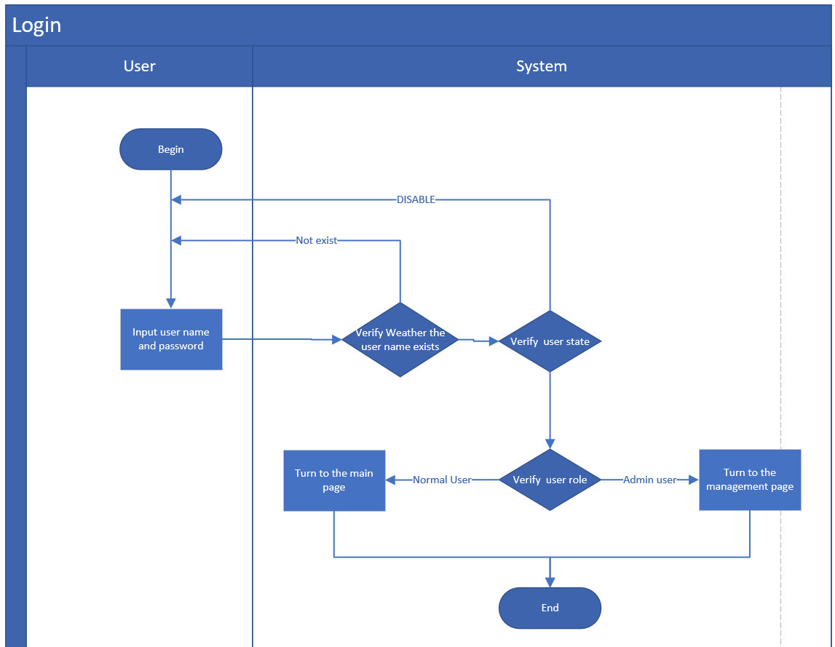

#### BP-003 View Goods Details

|  |  |  |
| --- | --- | --- |
| User case name: | View Goods Details | |
| Scenario: | View Goods Details | |
| Triggering event: | User click on an item in the list of items | |
| Description: | The purpose of this use case is to view goods details | |
| Actors: | User/Administrator | |
| Stakeholders: |  | |
| Preconditions: |  | |
| Postconditions: |  | |
| Flow of activities: | Actor | System |
| View Goods Details | The system can display the detailed page of an item |
|
| Exception conditions: |  | |

Diagram (Add)

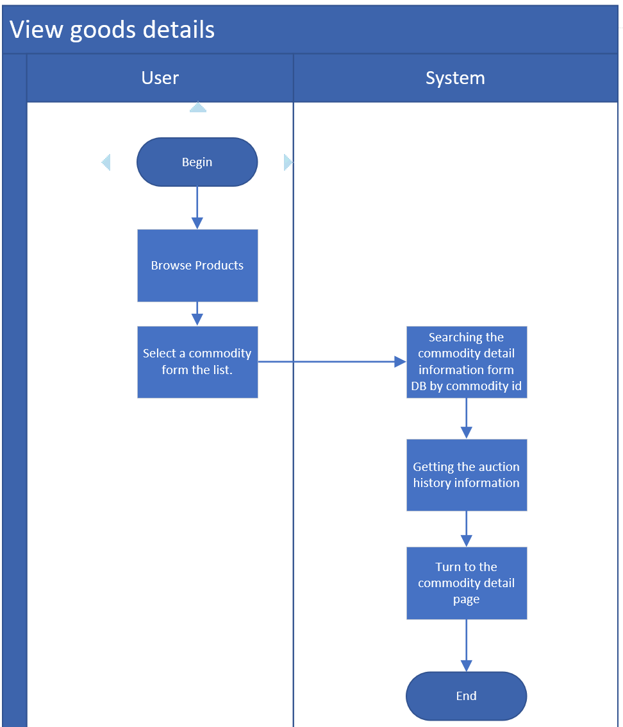

#### BP-004 Auction

|  |  |  |
| --- | --- | --- |
| User case name: | Auction | |
| Scenario: | Auction | |
| Triggering event: | User input the price he/she want to pay, and click on the  auction button | |
| Description: | The purpose of this use case is to auction when user has an interested item | |
| Actors: | User | |
| Stakeholders: |  | |
| Preconditions: | User has an account | |
| Postconditions: |  | |
| Flow of activities: | Actor | System |
| User input the price and then click on the auction button | The system will verify if the price is higher than the current price. If it is higher, it will be successful. If it is lower, it will be failed |
|
| Exception conditions: | If user input the price is lower than the current price | |

Diagram (Add)

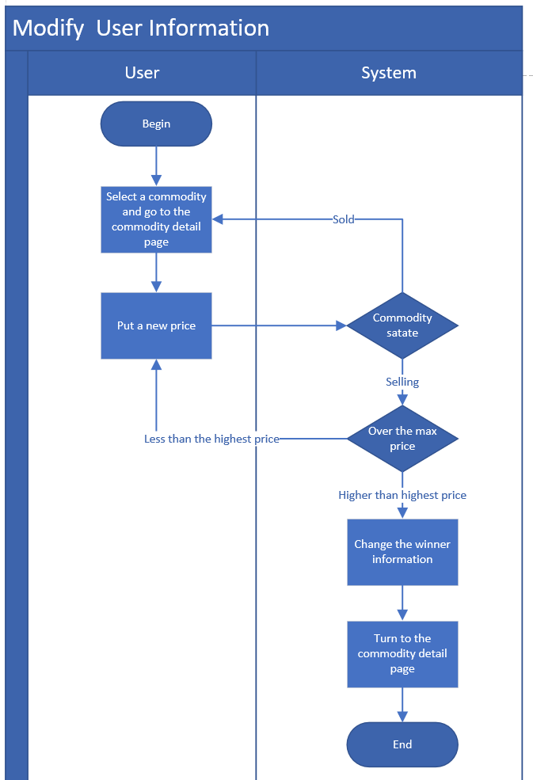

#### BP-005 Modify Personal Information

|  |  |  |
| --- | --- | --- |
| User case name: | Modify Personal Information | |
| Scenario: | Modify Personal Information | |
| Triggering event: | User wants to change his/her information | |
| Description: | The purpose of this use case is to explain how is the process of changing personal information | |
| Actors: | User/Administrator | |
| Stakeholders: |  | |
| Preconditions: | User updates his/her information | |
| Postconditions: |  | |
| Flow of activities: | Actor | System |
| User updates his/her  information and click  on the confirm button | The system will get the information user changed, and update the information in the database. |
|
| Exception conditions: |  | |

Diagram (Add)

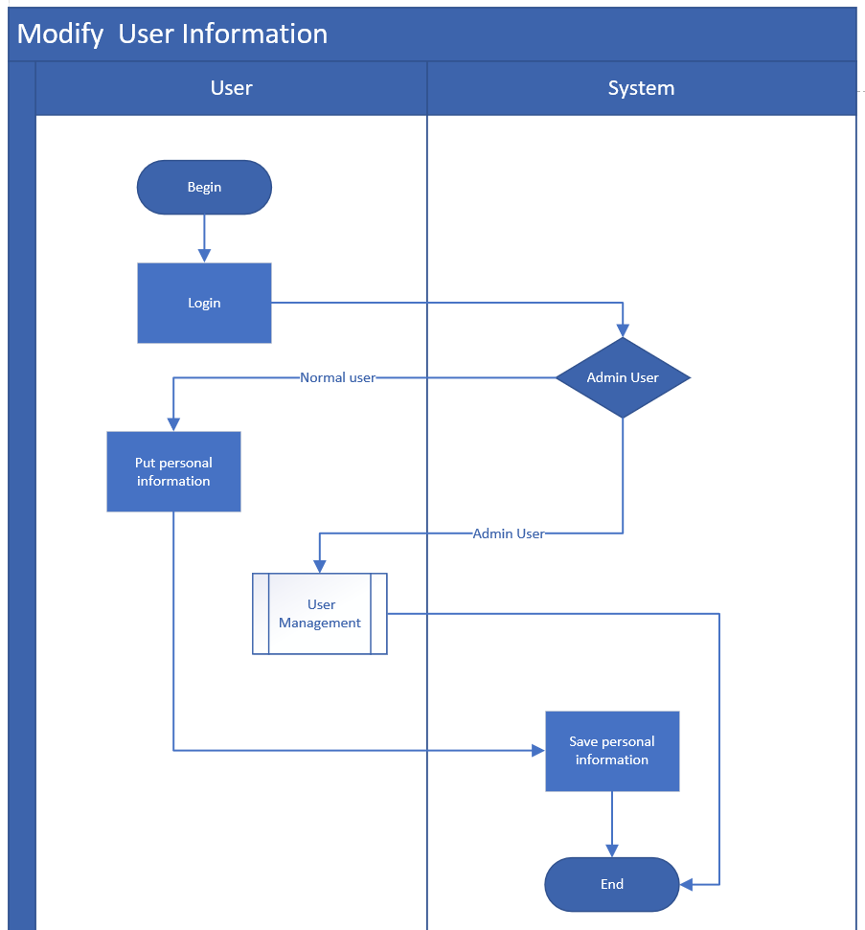

#### BP-006 Appointment For Pickup

|  |  |  |
| --- | --- | --- |
| User case name: | Appointment For Pickup | |
| Scenario: | Appointment For Pickup | |
| Triggering event: | User wins the auction | |
| Description: | The purpose of this use case is to make an appointment  for pickup after user wins an auction | |
| Actors: | User | |
| Stakeholders: |  | |
| Preconditions: | User wins an auction | |
| Postconditions: |  | |
| Flow of activities: | Actor | System |
| User input his/her name, telephone number and pickup time and click on the submit button | The system will put the information into the database, and administrator can see them |
|
| Exception conditions: |  | |

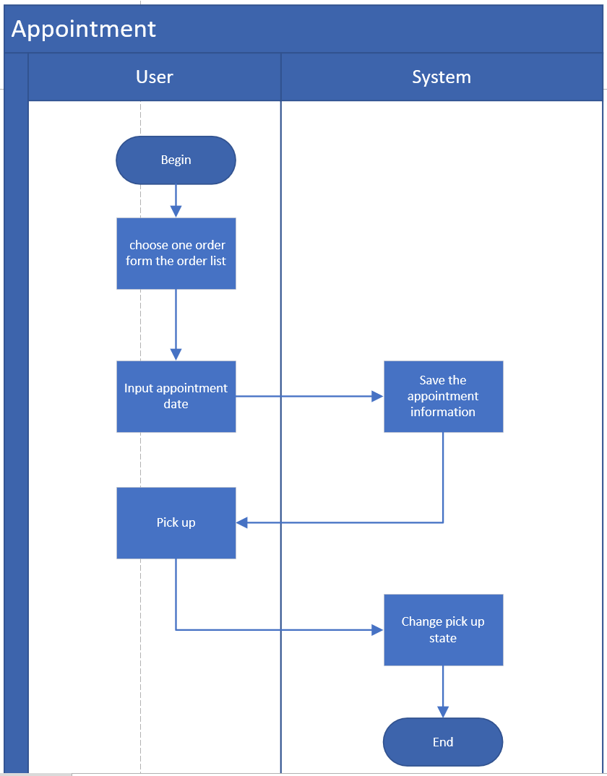

#### BP-007 Upload Goods

|  |  |  |
| --- | --- | --- |
| User case name: | Upload Goods | |
| Scenario: | Upload Goods | |
| Triggering event: | Administrator click on the upload button | |
| Description: | The purpose of this use case is to support administrator to upload some goods for users to auction | |
| Actors: | Administrator | |
| Stakeholders: |  | |
| Preconditions: | Administrator has the authority to upload | |
| Postconditions: |  | |
| Flow of activities: | Actor | System |
| Administrator clicks on  the upload button | The system can display the page for administrator to upload goods |
|
| Exception conditions: |  | |

Diagram (Add)

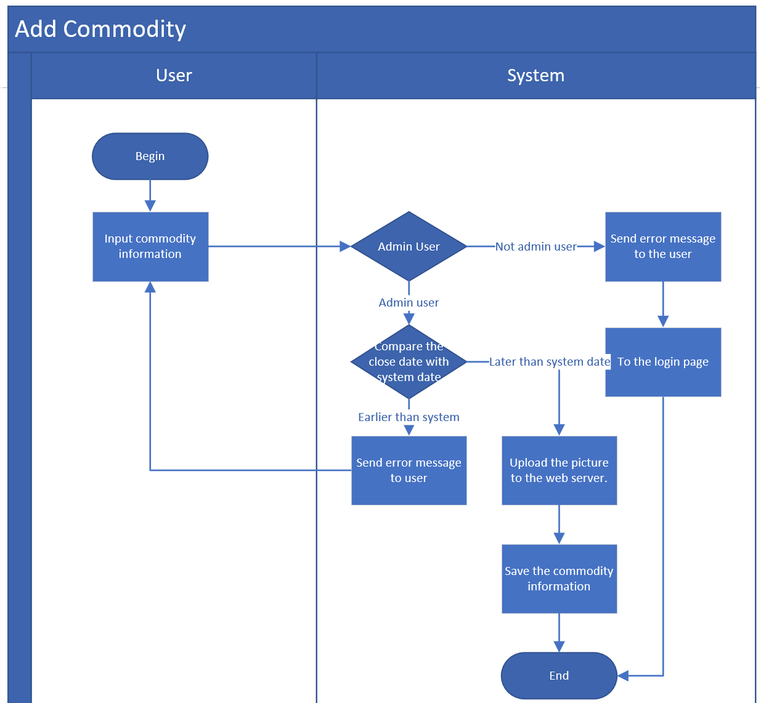

#### BP-008 Modify Goods

|  |  |  |
| --- | --- | --- |
| User case name: | Modify Goods | |
| Scenario: | Modify Goods | |
| Triggering event: | Administrator modifies goods information | |
| Description: | The purpose of this use case is to support administrator to modify goods information | |
| Actors: | Administrator | |
| Stakeholders: |  | |
| Preconditions: | Administrator has the authority to modify | |
| Postconditions: |  | |
| Flow of activities: | Actor | System |
| Administrator modifies goods information | The system can update the information and update data in the database |
|
| Exception conditions: |  | |

Diagram (Add)

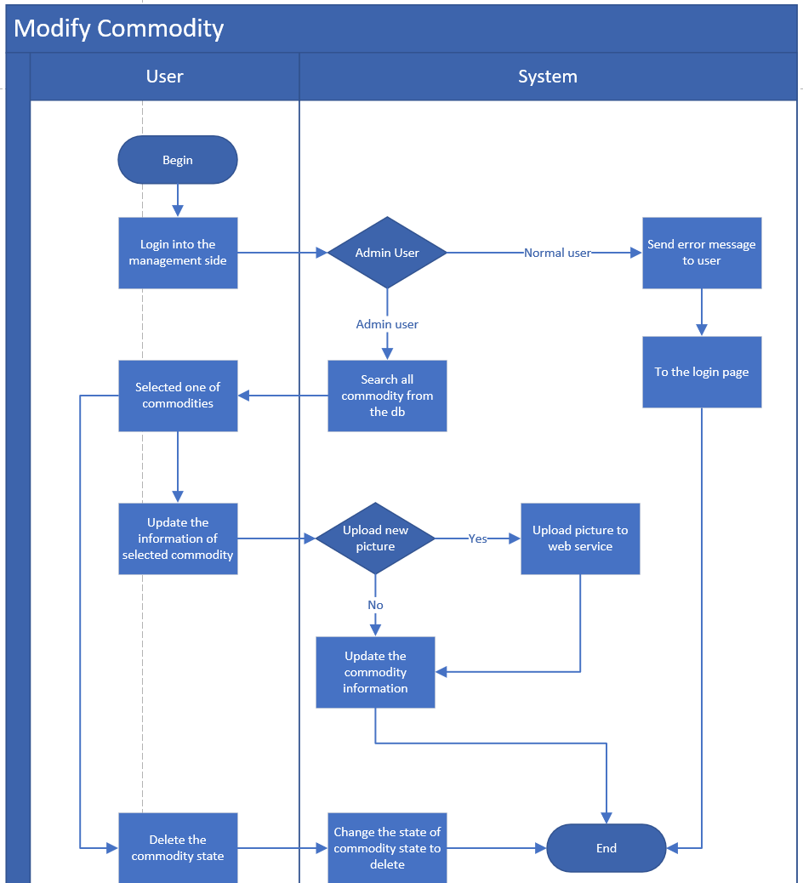

#### BP-009 User Management

|  |  |  |
| --- | --- | --- |
| User case name: | User Management | |
| Scenario: | User Management | |
| Triggering event: | Administrator changes user's condition | |
| Description: | The purpose of this use case is to support administrator to change user's condition, such as active, deactive, add and delete | |
| Actors: | Administrator | |
| Stakeholders: |  | |
| Preconditions: | Administrator has the authority | |
| Postconditions: |  | |
| Flow of activities: | Actor | System |
| Administrator changes user's condition, such as active, deactive, add and delete | The system will execute the actions to limit user's condition |
|
| Exception conditions: |  | |

Diagram (Add)

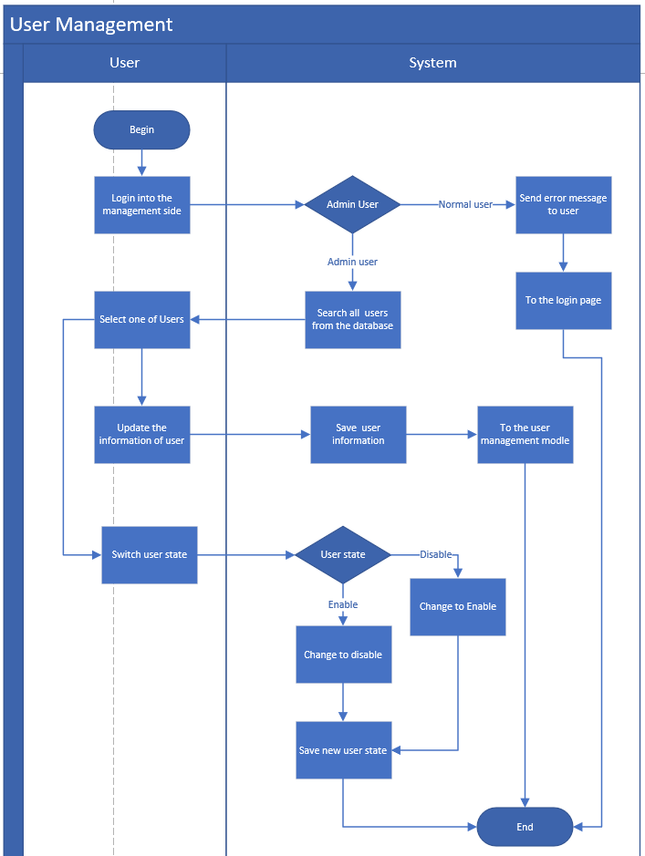

#### BP-010 Find the password

|  |  |  |
| --- | --- | --- |
| User case name: | Find the password | |
| Scenario: | Forget the password and change to a new one. | |
| Triggering event: | When User forget their password | |
| Description: | When User forget their password, then they want to change to the new password. The user can input the email address or phone and user name to change to new password. | |
| Actors: | Users. | |
| Stakeholders: |  | |
| Preconditions: | The user has account and can remember their user name and email address or phone number. | |
| Postconditions: |  | |
| Flow of activities: | Actor | System |
| Users input their user name and email address or phone number. | Compare the user name and the email address or phone number with the system. If the information which user input is correct, the system provide a changing password opportunity. |
|
| Exception conditions: |  | |

Diagram (Add)

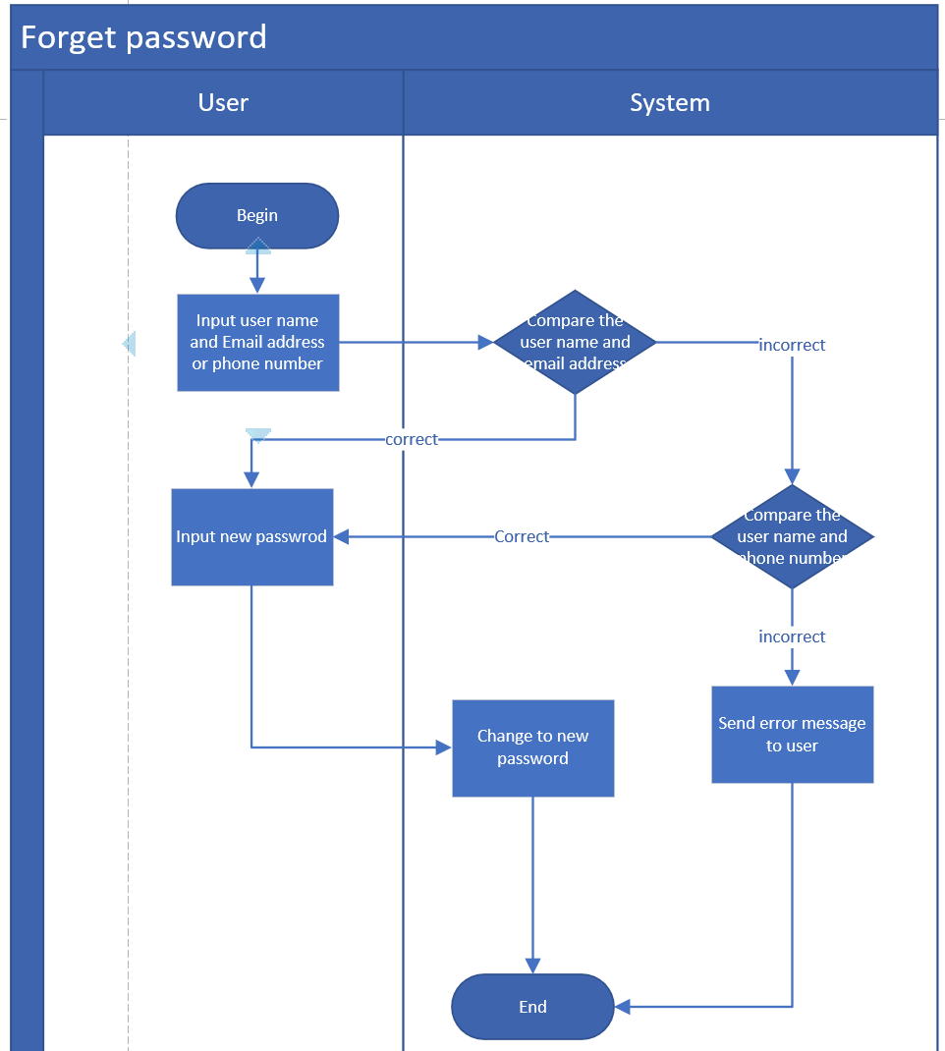

### Functional Requirements

#### Login Verification

This function is used to check whether the customer has the authority of the system. If they have authority, then users can log in normally. If there is no authority, users will be reminded to apply for registration

#### Goods Display

This function is used to display the goods in the second-hand store. Users can click any items to see the details of the goods

#### Auction

The feature allows users to view the auction time remaining, enter the auction price, and view the auction history

#### Appointment

After the auction is successful, users can fill in the booking information

#### Goods Management

This module supports the administrator to upload commodities, fill in goods information, set bidding time, price and other information.

### Non-functional Requirements

#### Layout and Colour

The online store’s layout and colour should be consistent with the layout and colour of the main church website.

#### Performance

The website can support multiple users to visit at the same time, to ensure the reliability of high concurrency.

Support mainstream browsers of PC terminal and mobile terminal (such as Chrome, Safari, IE).

## Technical requirements

如备份，还原等需求

# System specification

## Architecture Block Diagram

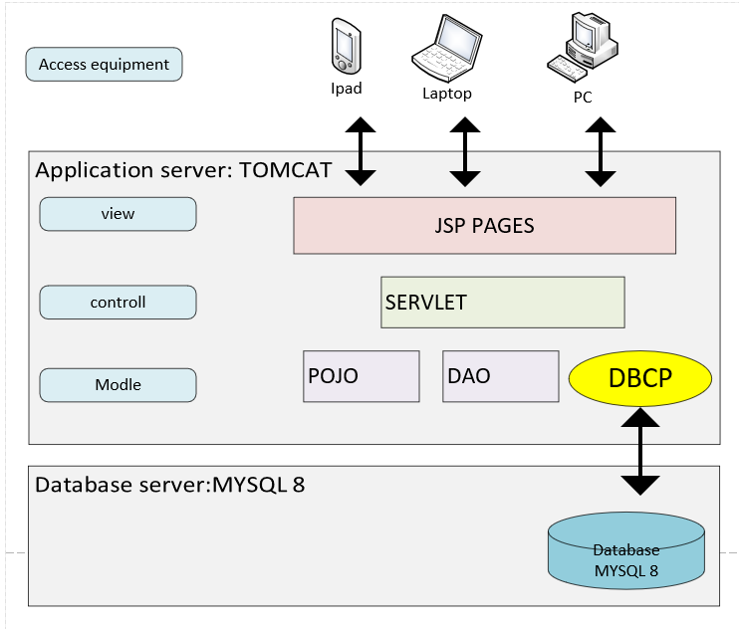

此图需换

## Class diagram

## Data Model

### Entity Relationship Diagram

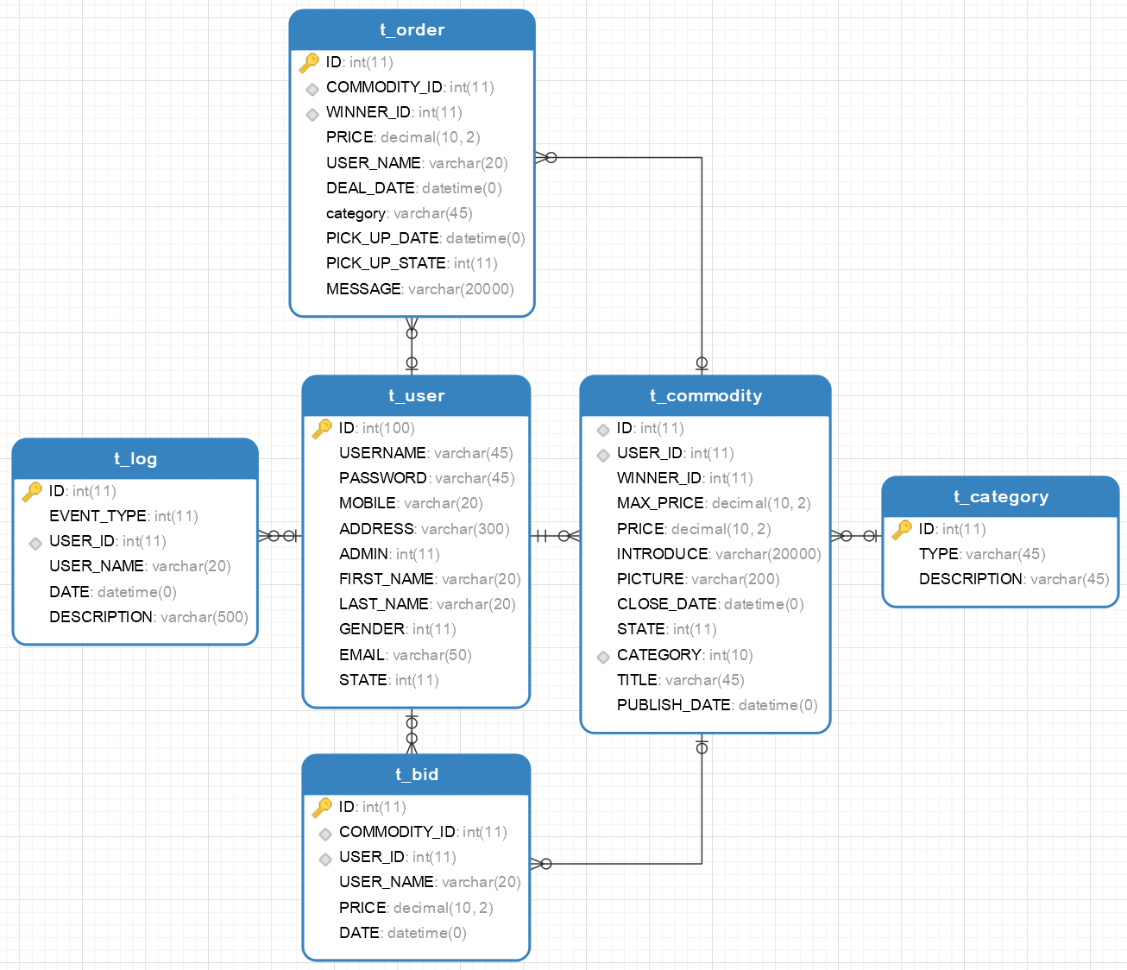

### Data Dictionary

|  |  |  |  |  |  |  |
| --- | --- | --- | --- | --- | --- | --- |
| TABLE_NAME | T_COMMODITY |  |  |  |  |  |
| COLUMN_NAME | DATATYPE | PK | FK | NOT NULL | DEFAULT | REMARKS |
| ID | INT(11) | Y |  | Y |  |  |
| USER_ID | INT(11) | N |  |  |  | PBULISHER USER ID |
| WINNER_ID | INT(11) | N | T_USER.ID |  |  |  |
| MAX_PRICE | DECIMAL(10,2) | N |  |  |  |  |
| PRICE | DECIMAL(10,2) | N |  | Y |  |  |
| INTRODUCE | VARCHAR(200) | N |  |  |  |  |
| PICTURE | VARCHAR(200) | N |  |  |  |  |
| CLOSE_DATE | DATETIME | N |  | Y |  |  |
| STATE | INT(11) | N |  | Y |  | 1:SOLD，  2:SELLING ， 3:DELETED |
| CATEGORY | INT(11) | N |  |  |  |  |
| TITLE | VARCHAR(45) | N |  | Y |  |  |
| PUBLISH_DATE | DATETIME | N |  | Y |  |  |

|  |  |  |  |  |  |  |
| --- | --- | --- | --- | --- | --- | --- |
| TABLE_NAME | T_USER |  |  |  |  |  |
| COLUMN_NAME | DATATYPE | PK | FK | NOT NULL | DEFAULT | REMARKS |
| ID | INT(11) | Y |  | Y |  |  |
| USERNAME | VARCHAR(20) | N |  | Y |  |  |
| FIRST_NAME | VARCHAR(20) | N |  |  |  |  |
| LAST_NAME | VARCHAR(20) | N |  |  |  |  |
| PASSWORD | INT(11) | N |  | Y |  |  |
| GENDER | INT(11) | N |  |  |  |  |
| MOBILE | VARCHAR(20) | N |  |  |  |  |
| ADDRESS | VARCHAR(300) | N |  |  |  | 1:ADMIN ,  2: NORMAL USER |
| ADMIN | INT(11) | N |  |  | 1 |  |
| EMAIL | VARCHAR(50) | N |  |  |  |  |
| STATE | INT(11) | N |  | Y |  | 1:ENABLE, 2: DISABLE |

|  |  |  |  |  |  |
| --- | --- | --- | --- | --- | --- |
| TABLE_NAME | T_BID |  |  |  |  |
| COLUMN_NAME | DATATYPE | PK | FK | NOT NULL | DEFAULT |
| ID | INT(11) | Y |  |  |  |
| COMMODITY_ID | INT(11) | N | T_COMMODITY.ID |  |  |
| USER_ID | INT(11) | N | T_USER.ID |  |  |
| USER_NAME | VARCHAR(20) | N |  |  |  |
| PRICE | DECIMAL(10,2) | N |  |  |  |
| DATE | DATETIME | N |  |  | CURRENT_TIMESTAMP |

|  |  |  |  |  |  |
| --- | --- | --- | --- | --- | --- |
| TABLE_NAME | T_LOG |  |  |  |  |
| COLUMN_NAME | DATATYPE | PK | FK | NOT NULL | DEFAULT |
| ID | INT(11) | Y |  |  |  |
| EVENT_TYPE | INT(11) | N |  |  |  |
| USER_ID | INT(11) | N | T_USER.ID |  |  |
| USER_NAME | VARCHAR(20) | N |  |  |  |
| DATE | DATETIME | N |  |  | CURRENT_TIMESTAMP |
| DESCRIPTION | VARCHAR(500) | N |  |  |  |

|  |  |  |  |  |  |
| --- | --- | --- | --- | --- | --- |
| TABLE_NAME | T_ORDER |  |  |  |  |
| COLUMN_NAME | DATATYPE | PK | FK | NOT NULL | DEFAULT |
| ID | INT(11) | Y |  |  |  |
| COMMODITY_ID | INT(11) | N | T_COMMODITY.ID |  |  |
| WINNER_ID | INT(11) | N | T_USER.ID |  |  |
| USER_NAME | VARCHAR(20) | N |  |  |  |
| DEAL_DATE | DATETIME | N |  |  | CURRENT_TIMESTAMP |
| PICK_UP_DATE | DATETIME | N |  |  |  |
| PICK_UP_STATE | INT(11) | N |  |  |  |
| MESSAGE | VARCHAR(2000) | N |  |  |  |
| PRICE | DECIMAL(10,2) | N |  |  |  |

|  |  |  |  |  |  |
| --- | --- | --- | --- | --- | --- |
| TABLE_NAME | T_CATEGORY |  |  |  |  |
| COLUMN_NAME | DATATYPE | PK | FK | NOT NULL | DEFAULT |
| ID | INT(11) | Y |  | Y |  |
| TYPE | VARCHAR(20) | N |  |  |  |
| DESCRIPTION | VARCHAR(500) | N |  |  |  |

## Use Case Diagram

Commodity and auction.

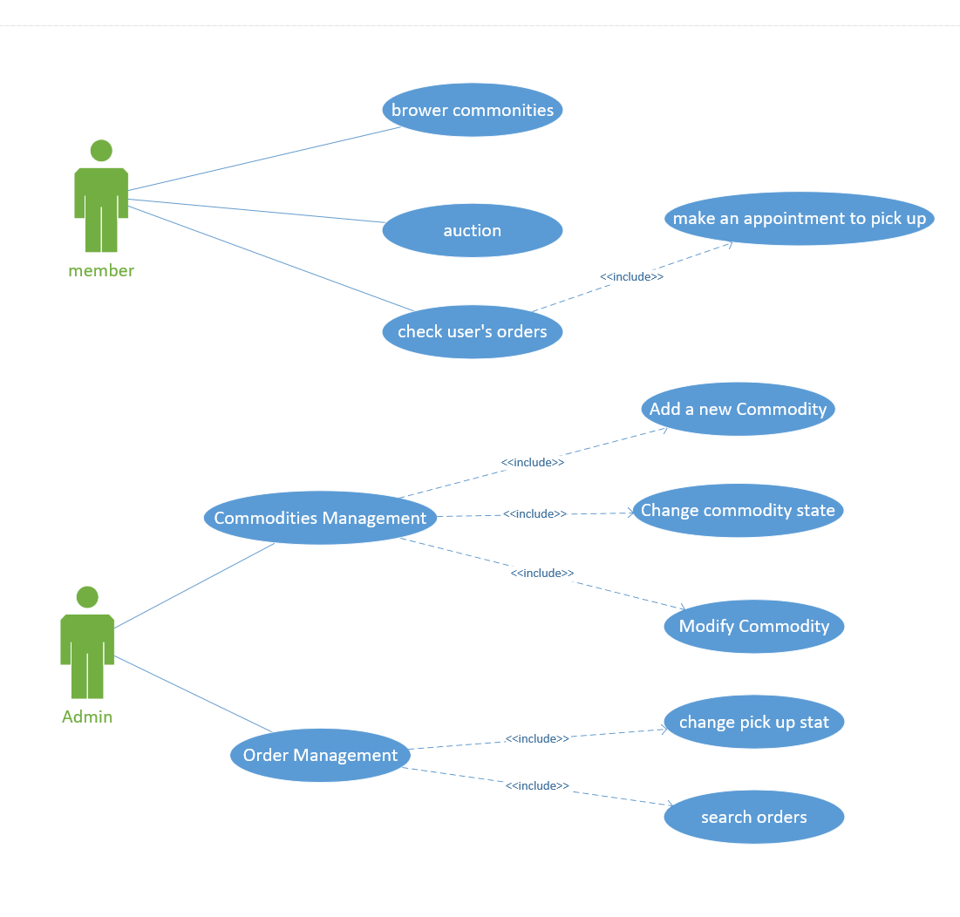

User management.

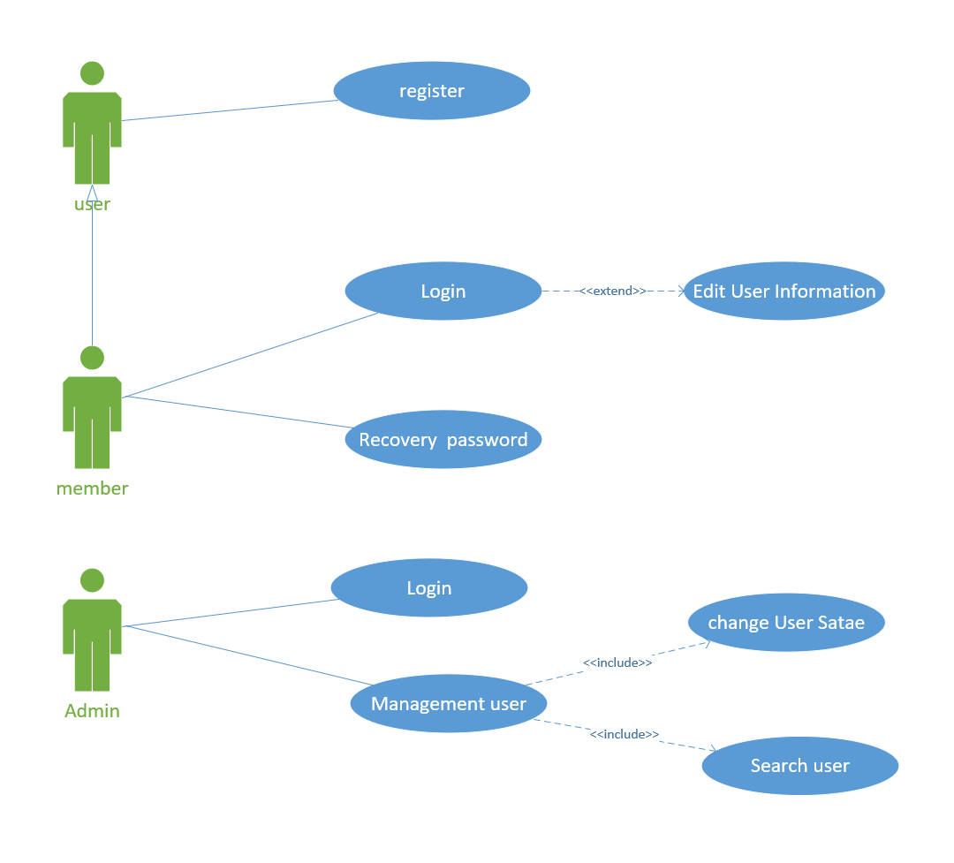

# Prototype

## Log In

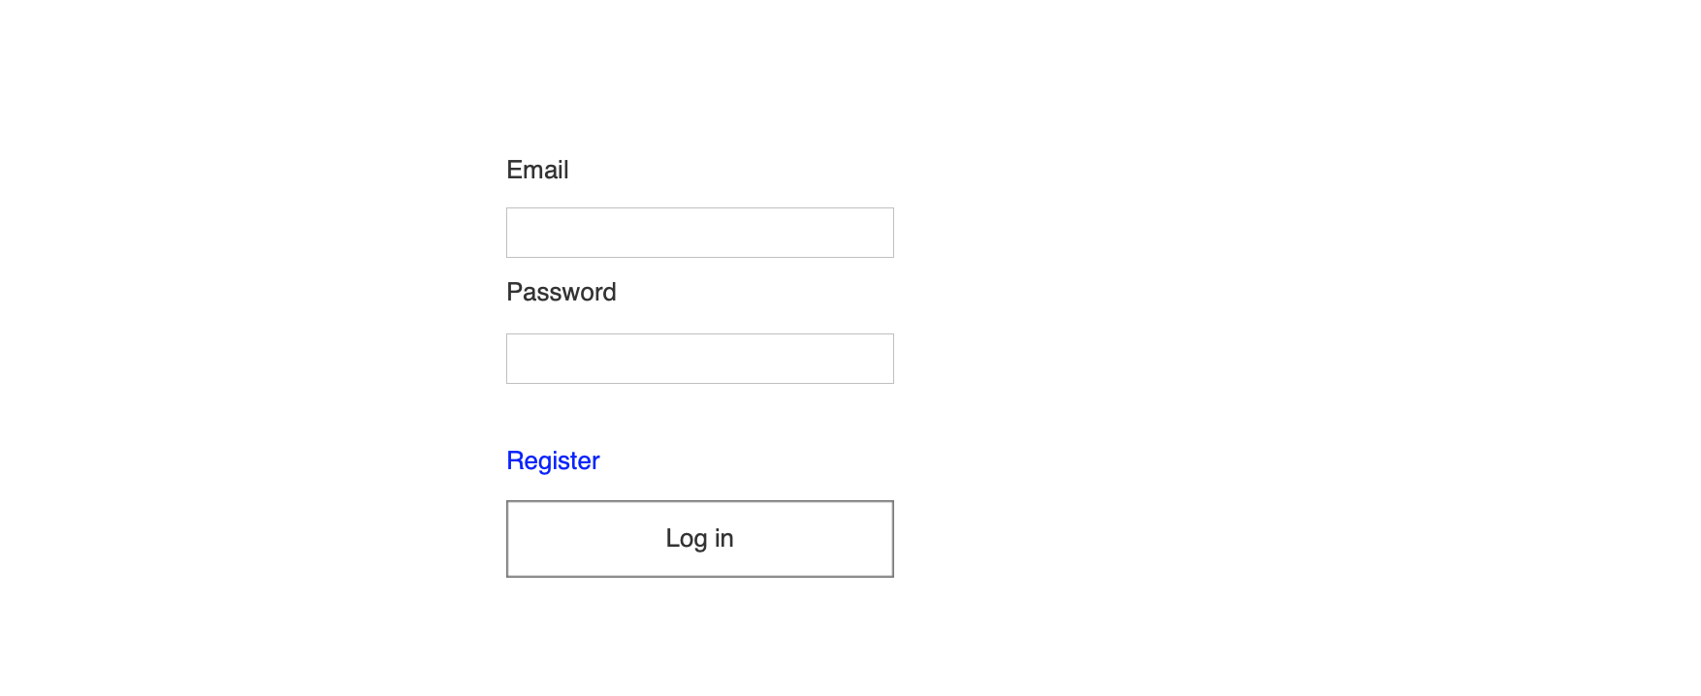

## Register

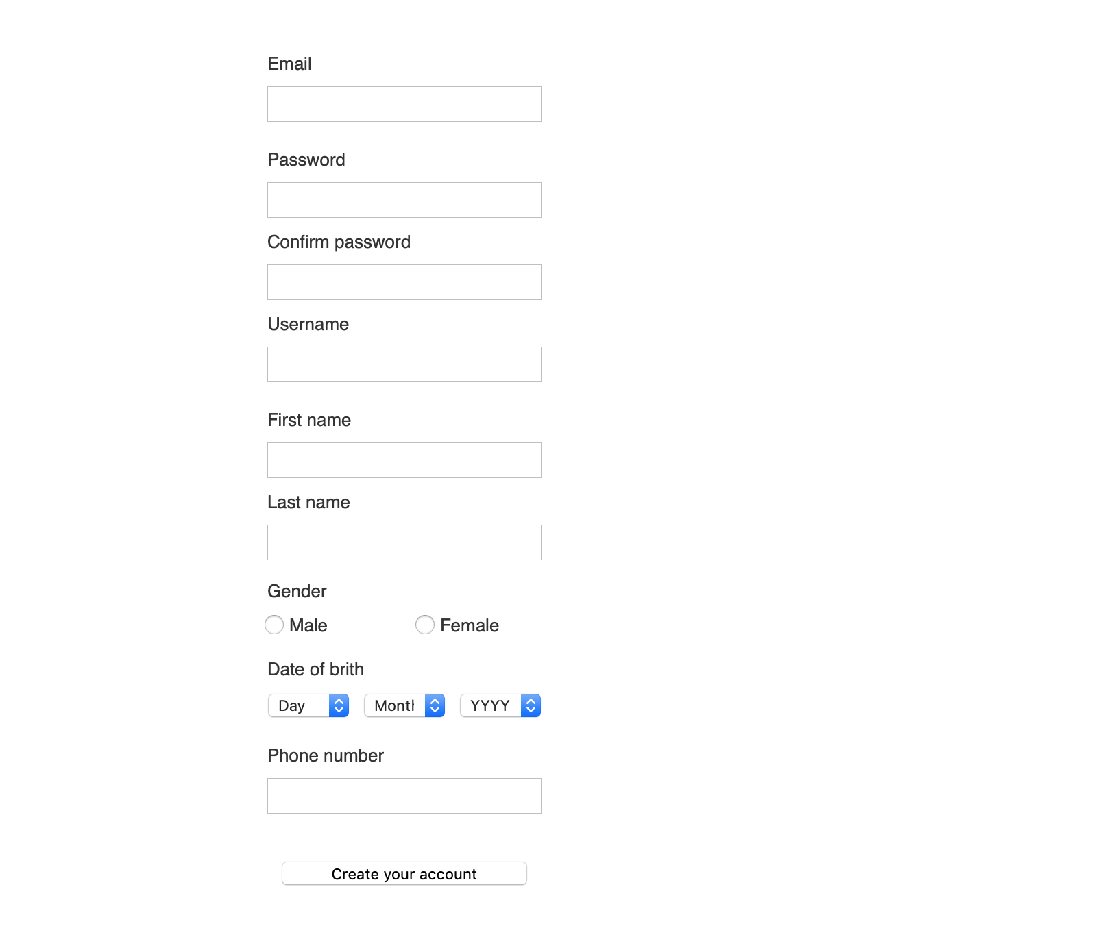

## Main Page

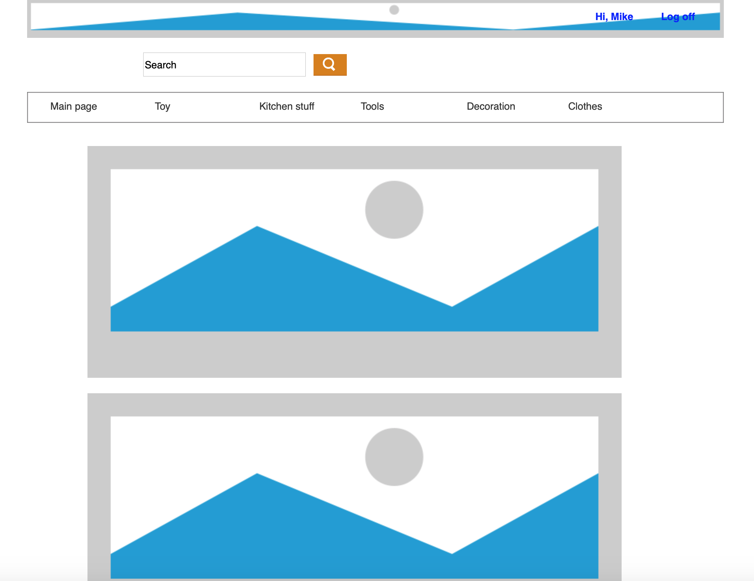

## Auction Page

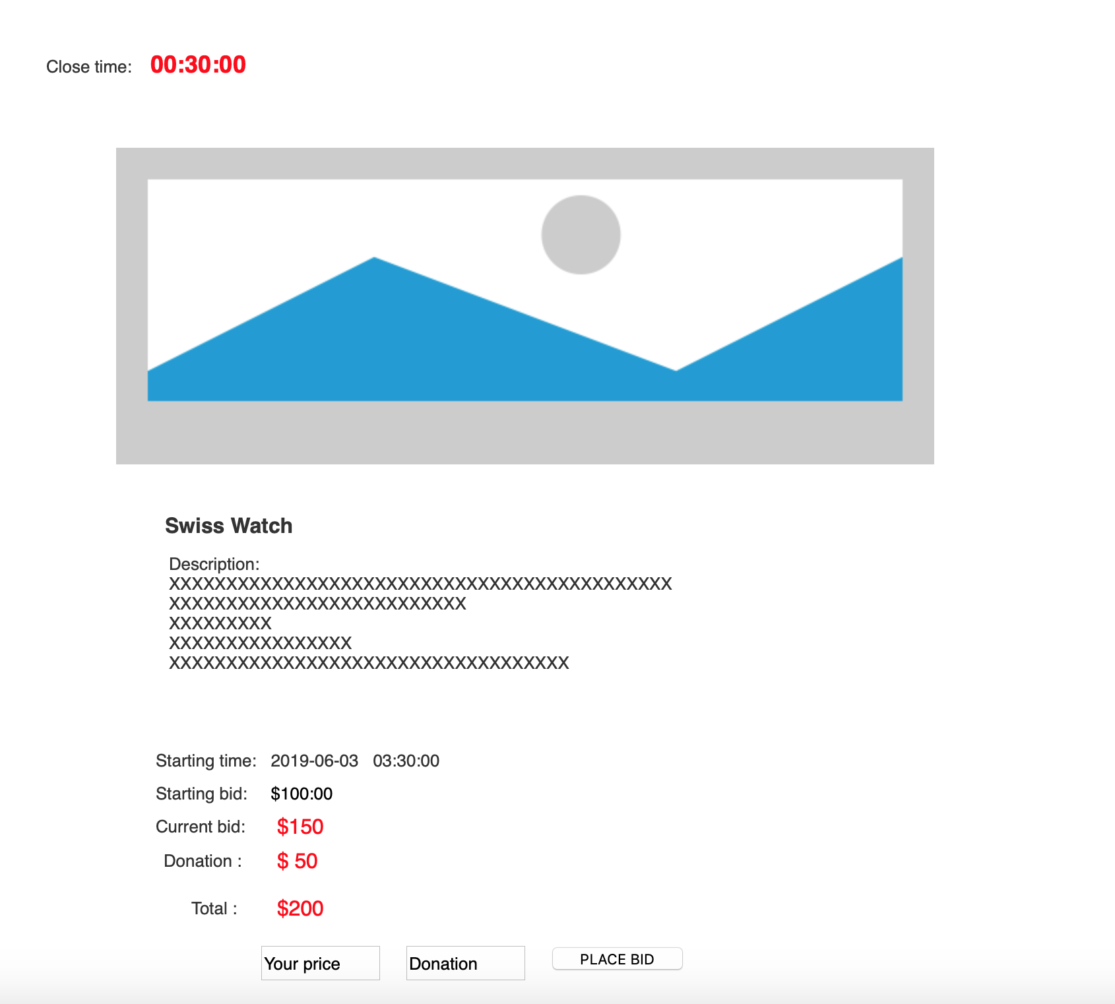

## My Space

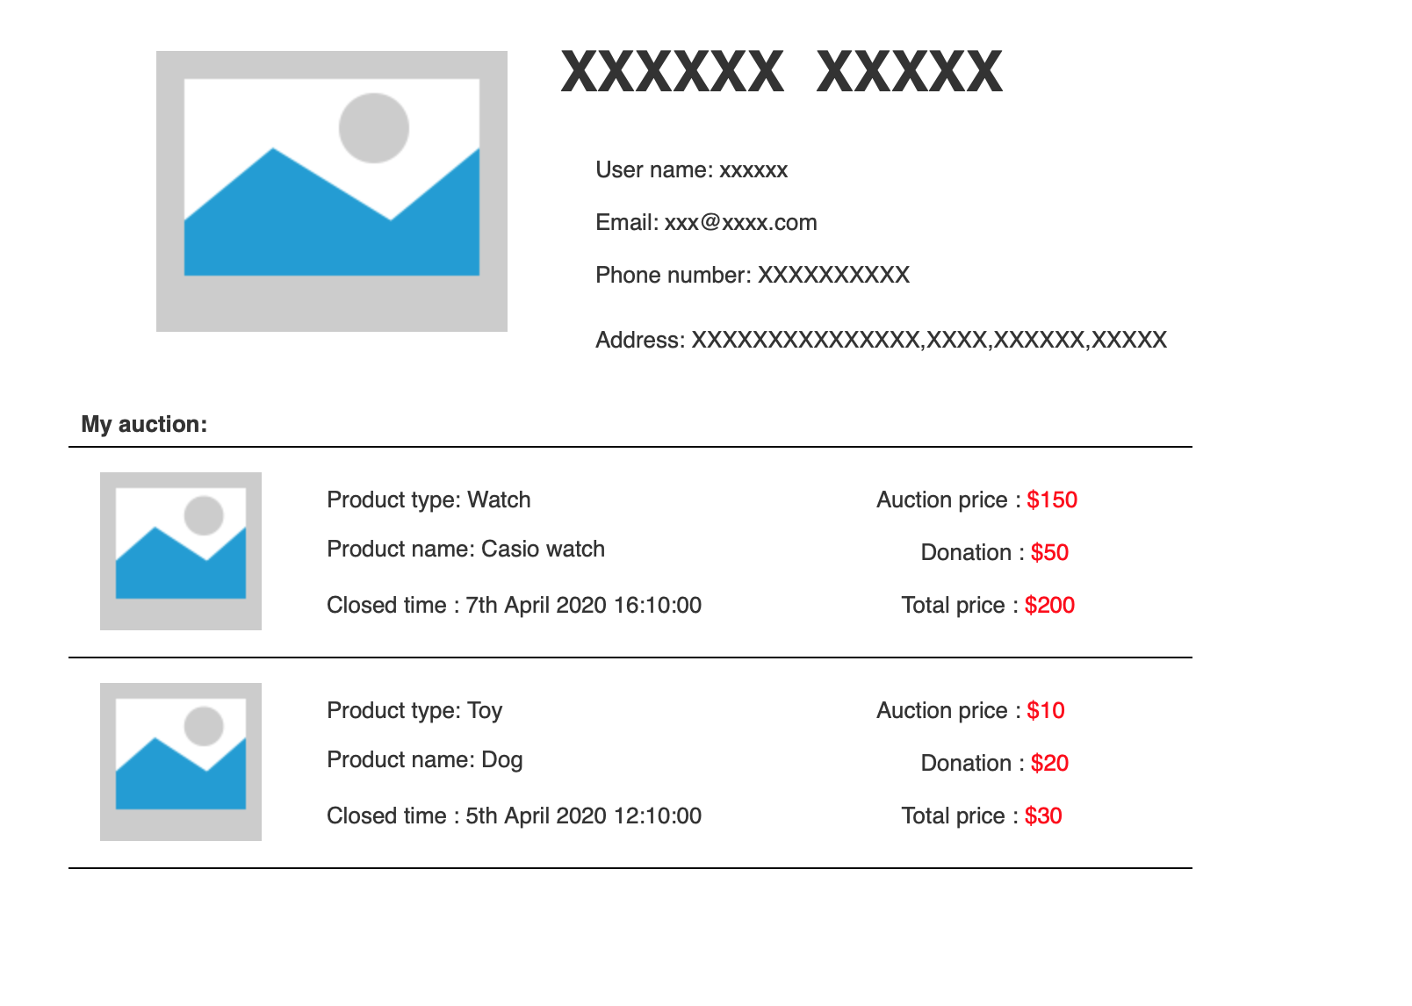

## Auction End

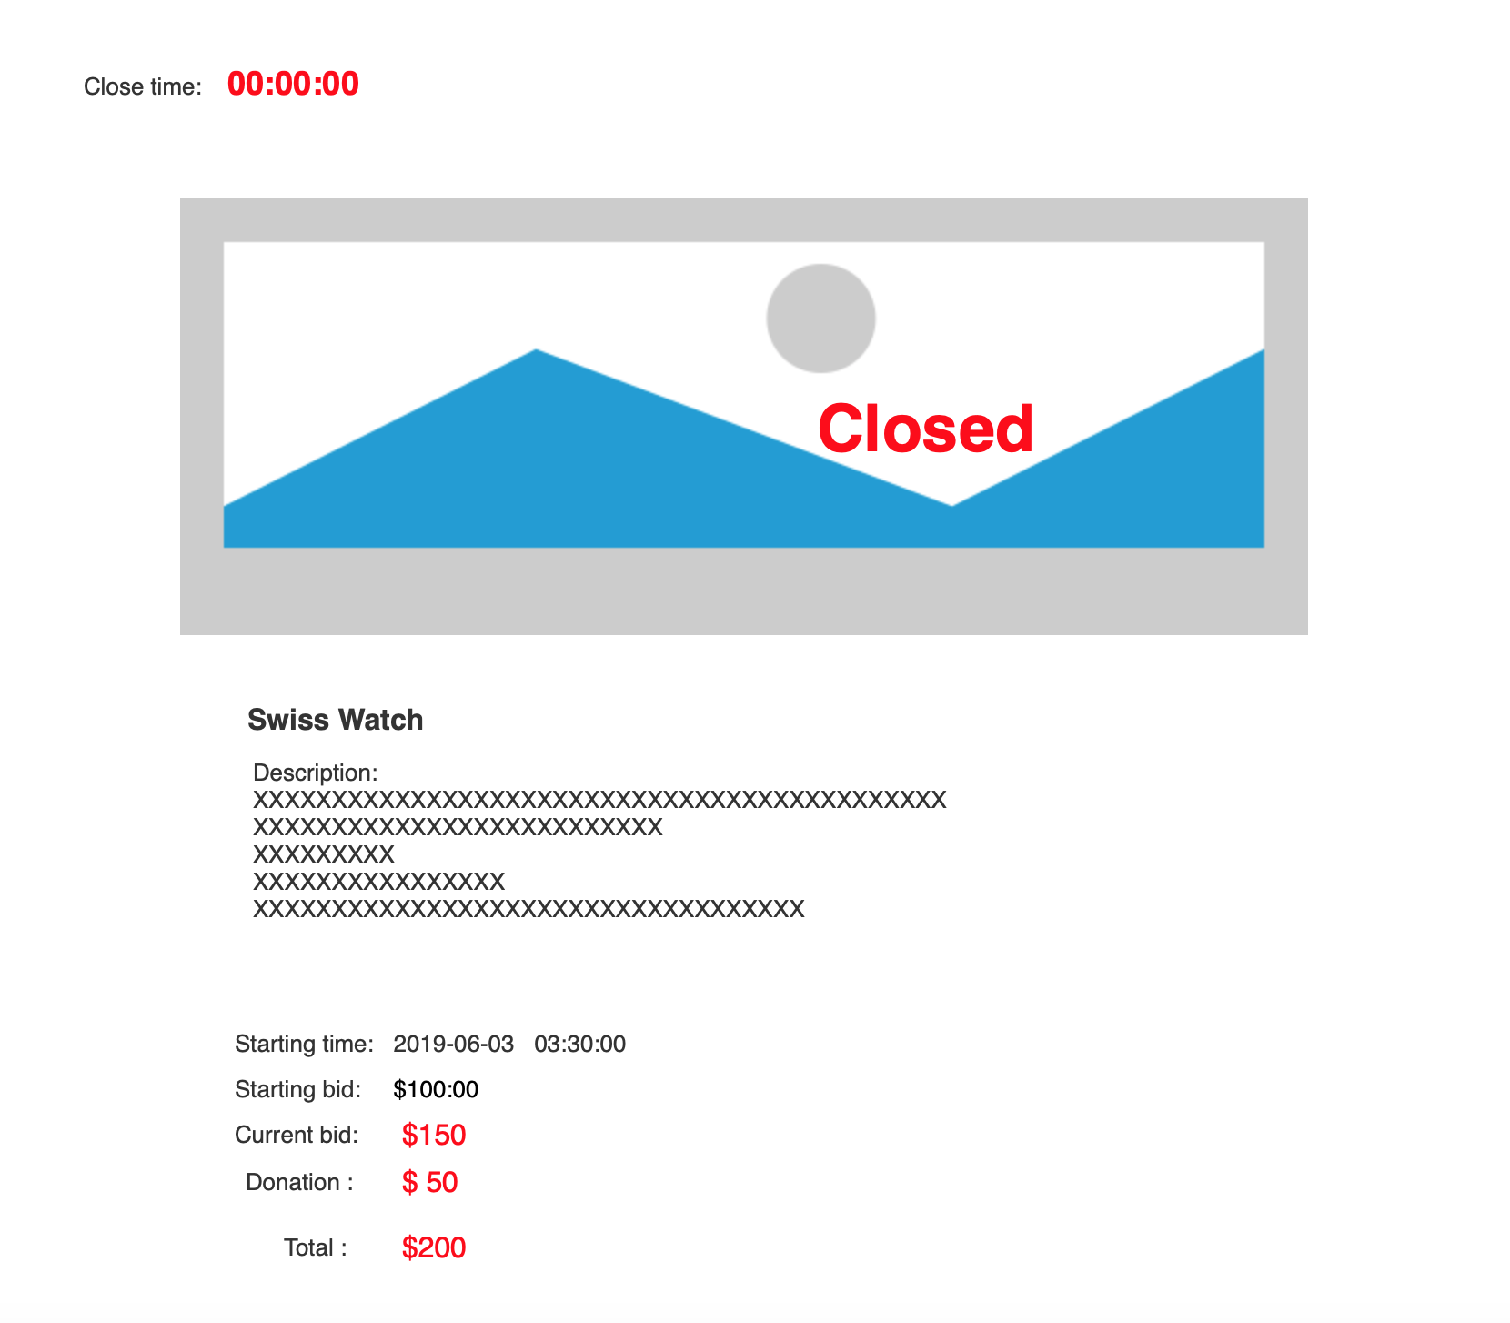

## My Space For Administrator

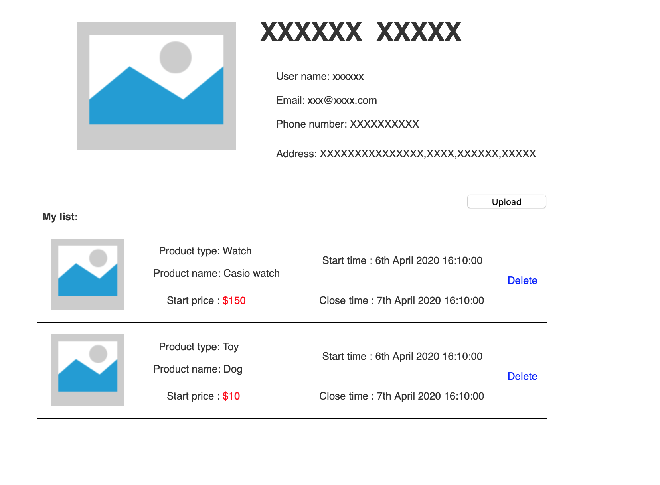

## Goods Management

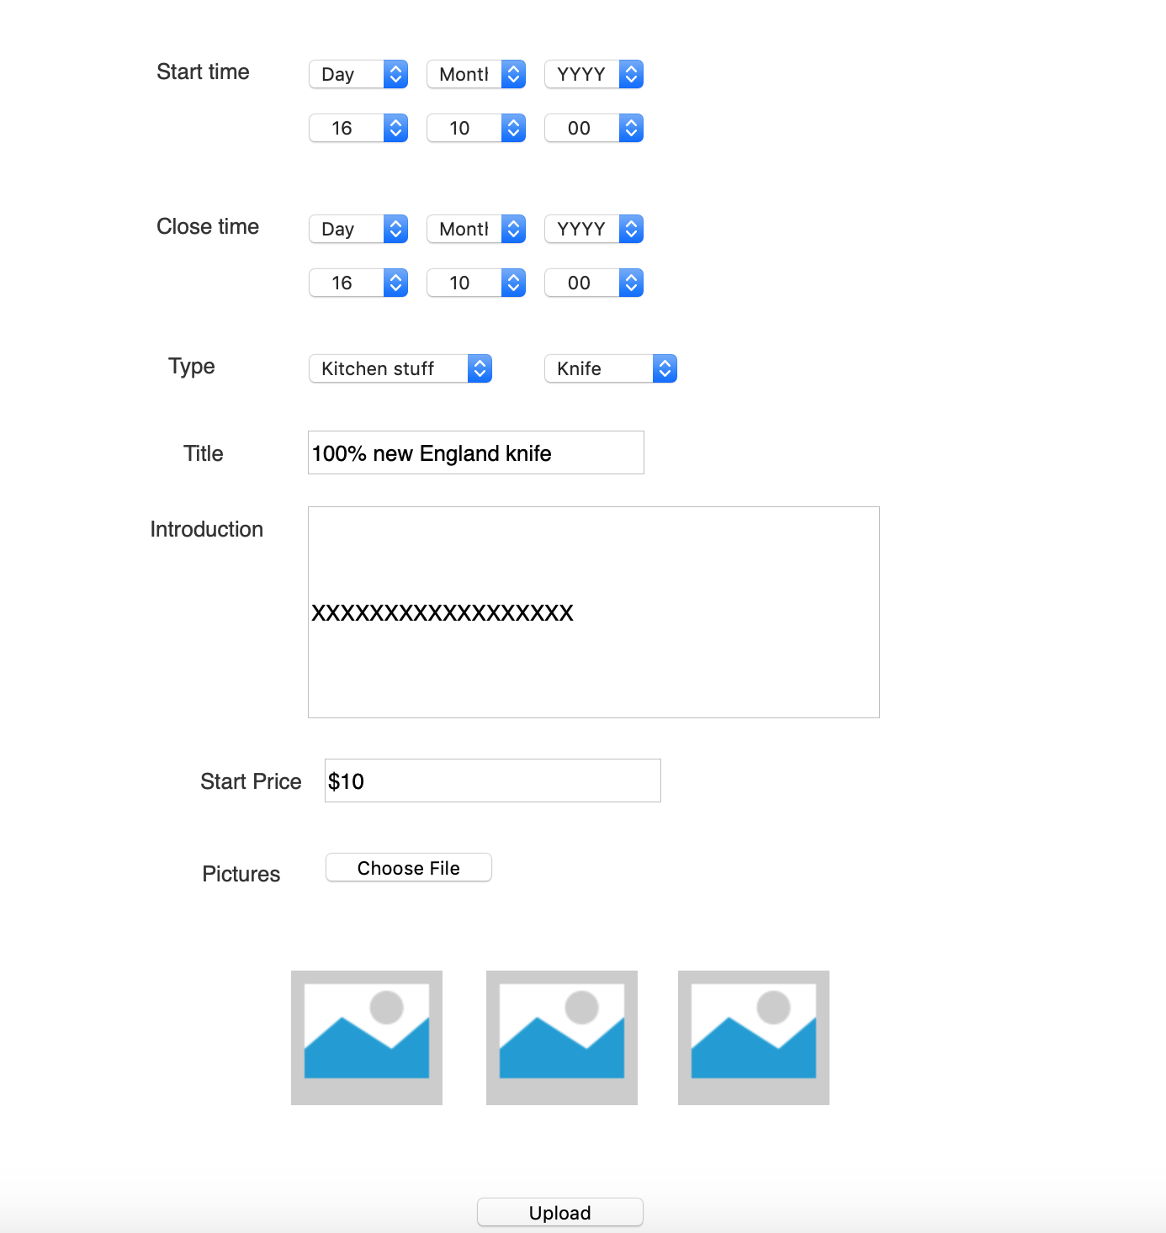

## About Us



## Contact Us

